Association rules

🡪Two famous method we use for association  
1. Aproiri ->word come from a priority

🡪To Market Basket Analysis

🡪Affinity analysis is used to perform Market Basket Analysis.

🡪Eg. Shampoo with conditioner.

2. Eclat

🡪If lift > 1 you can associate it.

Lift < 1 don’t associate them

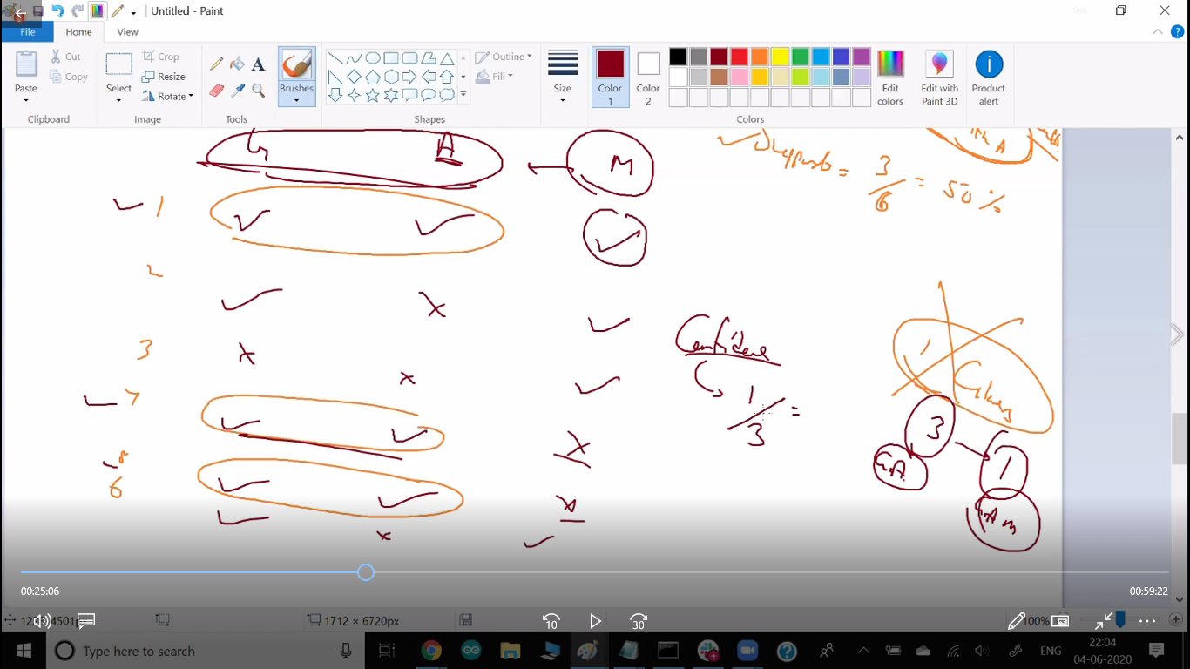

Lift = 0.33/0.5 < 1 don’t associate them.

Pip install apyori